Sales Trends Analysis Report

Retail Transaction Data Analysis
1. Introduction
This report analyzes retail transaction data to identify important sales trends and business insights. The analysis focuses on monthly and yearly sales performance, best-selling products, geographic sales distribution, and customer purchasing patterns. The objective is to help businesses understand sales behavior and make data-driven decisions to improve revenue and operational efficiency.
2. Dataset Overview
The dataset contains retail transaction information including:
- Transaction ID
- Date of Purchase
- Customer Name
- Product
- Total Items Purchased
- Total Cost (Revenue)
- Payment Method
- City
- Store Type
- Discount Applied
- Customer Category
- Season
- Promotion
Data Cleaning Summary
- No duplicate records were found.
- Missing values were identified only in the Promotion column.
- Date column was converted into proper datetime format.
- Additional columns were created for analysis:
  - Year
  - Month
  - Month Name
This prepared the dataset for trend analysis.
3. Monthly and Yearly Sales Trends
Key Findings
- Monthly analysis revealed fluctuations in sales across different months.
- Some months generated significantly higher revenue compared to others.
- Seasonal trends were observed during promotional periods and festive seasons.
Insights
- Peak sales months indicate strong customer demand.
- Low-performing months may require promotional campaigns.
- Yearly sales comparison helps track overall business growth.
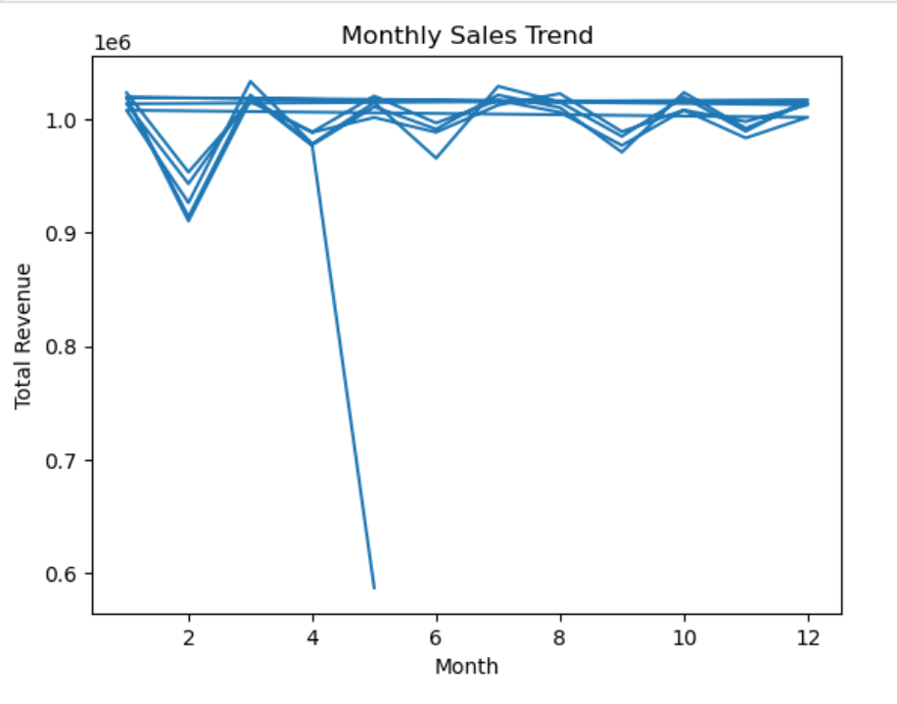

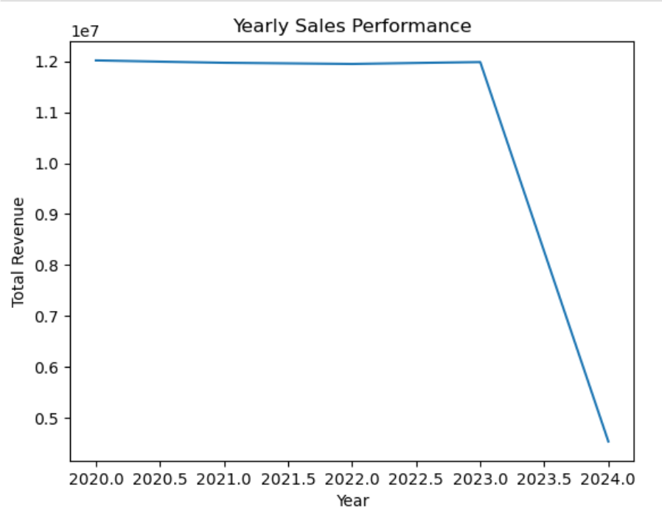
4. Best-Selling Products Analysis
The product-level analysis was conducted to identify items generating the highest sales.
Key Findings
- A small number of products contributed to a large portion of total revenue.
- The top-selling products had both high sales volume and strong revenue generation.
- Some products showed seasonal demand patterns.
Top Performing Products
(Insert table of top 5 or top 10 products)
Insights
- High-demand products should be prioritized in inventory planning.
- Businesses can increase profitability by promoting best-selling items.
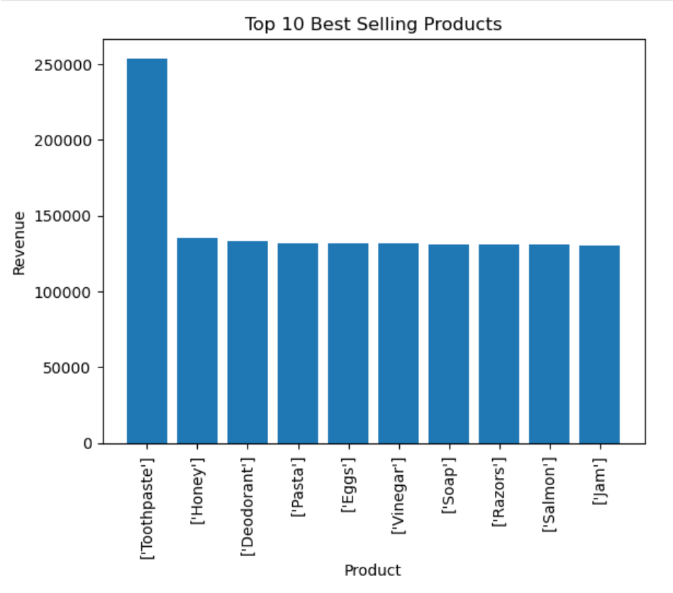
5. Category Performance Analysis
Sales were analyzed based on store types to understand which categories generate the most revenue.
Key Findings
- Certain store types contributed significantly more revenue.
- Customer preferences vary across store formats.
Insights
- Businesses should invest more in high-performing store categories.
- Marketing strategies can be tailored based on store performance.
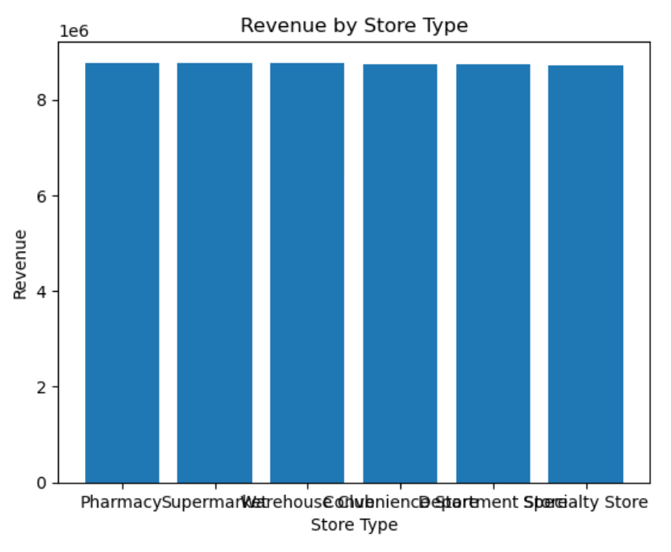
6. Geographic Sales Performance
Sales were analyzed based on city-level performance.
Key Findings
- Some cities generated significantly higher revenue than others.
- High-performing cities showed strong customer engagement and higher order volumes.
- Low-performing cities represent potential areas for business expansion.
Top Performing Cities
(Add your table here)
Insights
- Improve logistics and delivery services in high-demand cities.
- Implement targeted marketing campaigns in low-performing regions.
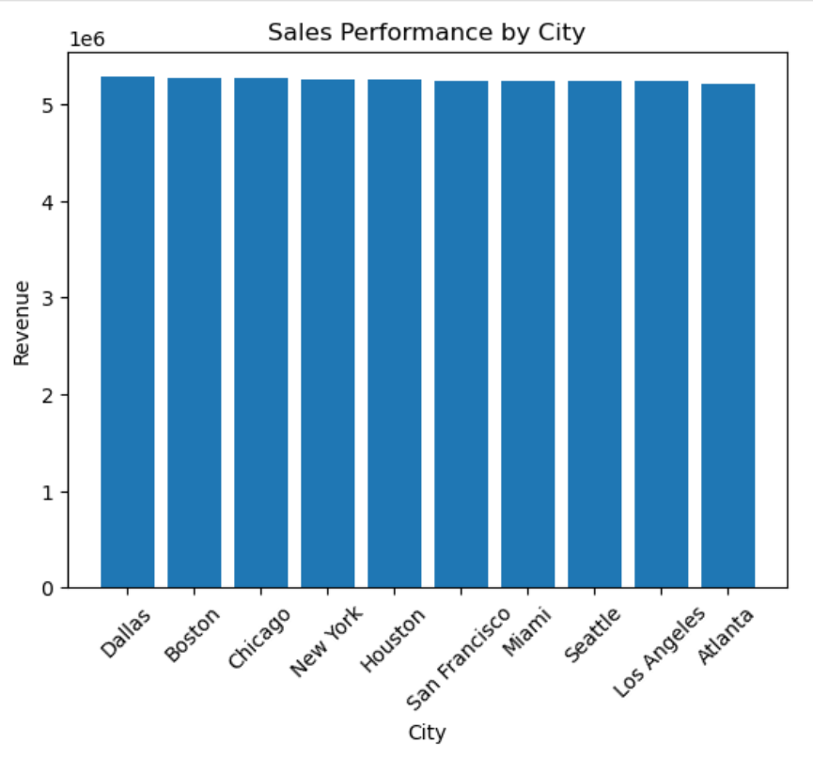

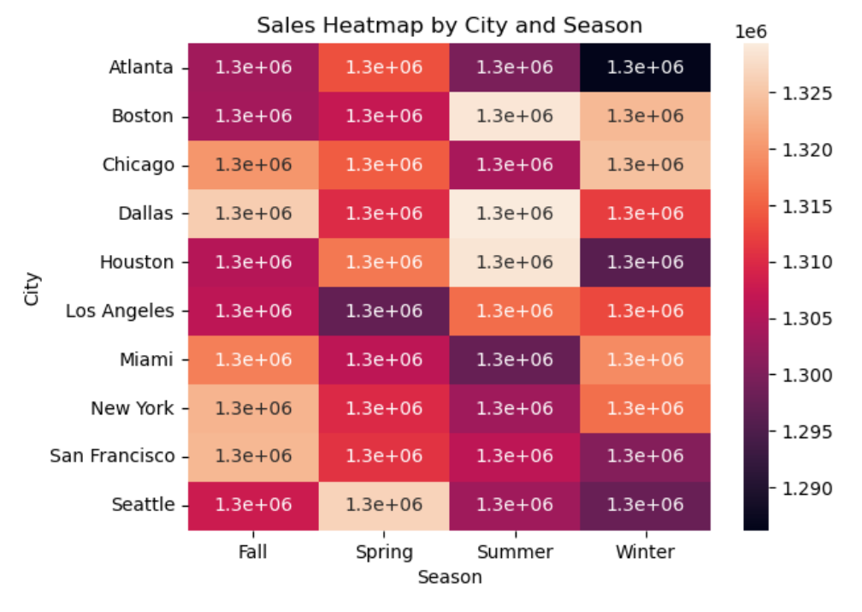
7. Key Business Insights
The analysis reveals several important trends:
- Sales show seasonal fluctuations across months.
- A small number of products generate most of the revenue.
- Certain cities contribute heavily to total sales.
- Promotional periods influence purchasing behavior.
- Geographic expansion opportunities exist in low-performing locations.

8. Business Recommendations
Based on the analysis, the following strategies are recommended:
Improve low-performing months with promotional campaigns
Increase stock availability for best-selling products
Focus marketing efforts on high-potential regions
Optimize supply chain and logistics in top-performing cities
Introduce targeted discounts and loyalty programs

9. Conclusion
This analysis provides valuable insights into sales performance across different dimensions, including time, products, and geography. These insights can help businesses optimize marketing strategies, improve inventory planning, and drive overall revenue growth.
10. Cleaned Dataset
The cleaned dataset used for this analysis has been attached as a CSV file named:
cleaned_sales_analysis_dataset.csv
This dataset includes processed and structured data with additional columns such as:
- Year
- Month
- Month Name
- Aggregated sales insights
A preview of the dataset is shown below.
